Tourist places:

statue of Liberty (EEUU)

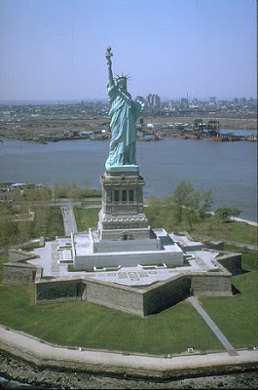

It is one of the most famous monuments in New York, the United States and around the world. It is located on Liberty Island south of the island of Manhattan.Their visits reach an average of 4.5 million tourists each year.

Mauricio and Fernando